Project Design Phase-II
Data Flow Diagram & User Stories

Date | 15 July 2026
Team ID | SWTID-2026-7950
Project Name | ONLINE COMPLAINT REGISTRATION
Maximum Marks | 4 Marks

Data Flow Diagrams:
A Data Flow Diagram (DFD) is a traditional visual representation of the information flows within a system. A neat and clear DFD can depict the right amount of the system requirement graphically. It shows how data enters and leaves the system, what changes the information, and where data is stored.
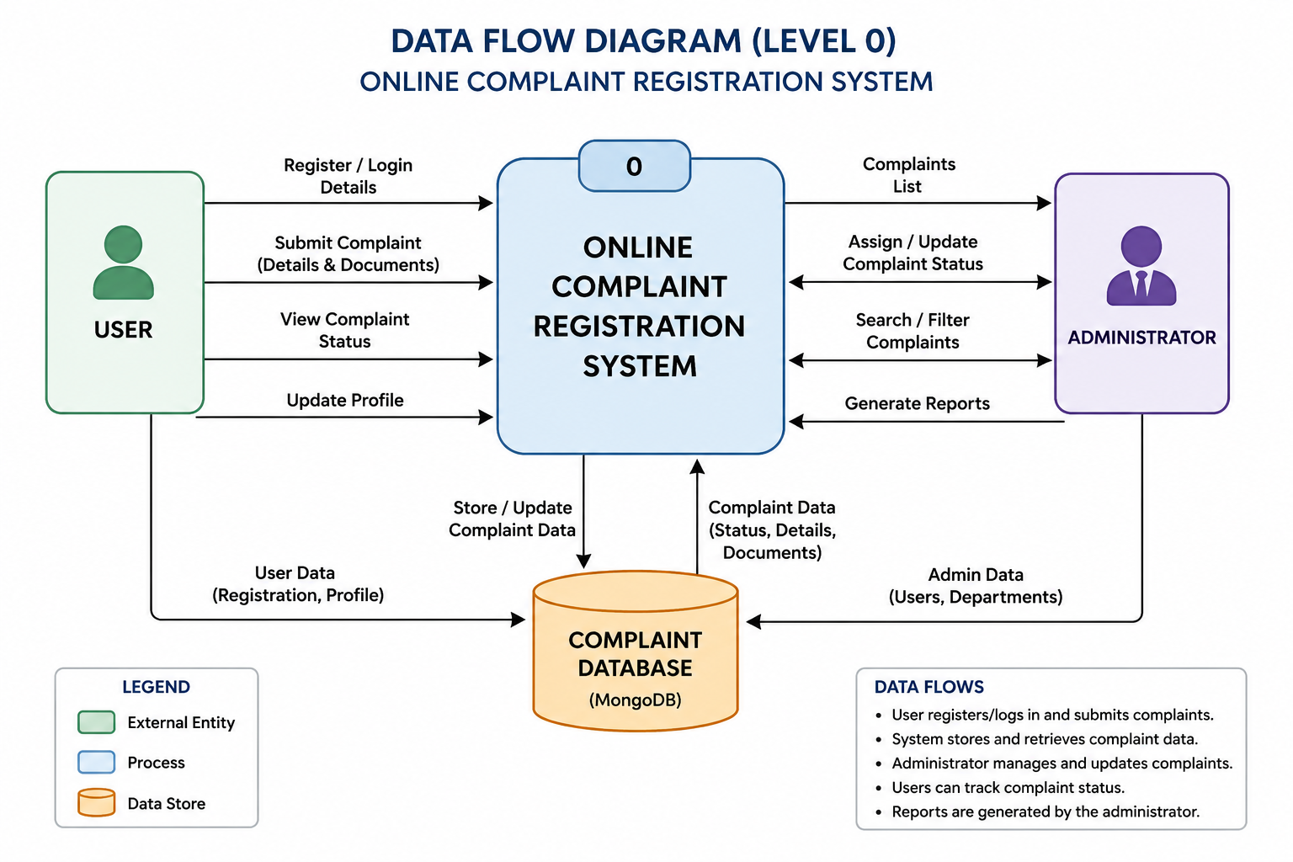
Flow Diagram

User Stories
User Type | Functional Requirement (Epic) | User Story Number | User Story / Task | Acceptance Criteria | Priority | Release
User | Registration | USN-1 | As a user, I can register an account by entering my name, email, phone number, and password. | The account is created successfully and the user can log in. | High | Sprint-1
User | Login | USN-2 | As a user, I can log in securely using my email and password. | The dashboard opens after successful authentication. | High | Sprint-1
User | Complaint | USN-3 | As a user, I can submit a complaint with category, description, priority, and attachments. | The complaint is stored successfully and a complaint ID is generated. | High | Sprint-1
User | Tracking | USN-4 | As a user, I can track the current status of my complaint. | The latest complaint status is displayed. | High | Sprint-2
User | Profile | USN-5 | As a user, I can update my profile information. | Profile changes are saved successfully. | Medium | Sprint-2
Administrator | Dashboard | USN-6 | As an administrator, I can view all complaints in the dashboard. | All complaints are listed with search and filters. | High | Sprint-2
Administrator | Complaint Management | USN-7 | As an administrator, I can assign complaints to departments. | The complaint is assigned successfully. | High | Sprint-3
Administrator | Complaint Management | USN-8 | As an administrator, I can update the complaint status and add remarks. | Users can view the updated complaint status. | High | Sprint-3
Administrator | Search & Reports | USN-9 | As an administrator, I can search, filter, and generate complaint reports. | Reports are generated accurately. | Medium | Sprint-4

